MatLab Toolkit App Manual

Written by: Bjorn Kierulf

Sponsored by MathWorks

Table of Contents

Introduction: 1

Installation and Updating: 2

App Overview: 2

States: 2

Processes: - figures 2

Plots: 3

3D Plot 4

Property Calculation 4

Phase detection 4

Linear interpolation 4

Property calculation by phase 5

Liquid 5

Liquid-vapor mixture 5

Vapor 5

Example of the process 5

Limitations 6

Example problem 7

States tab 7

Processes tab 7

Plots tab 8

P-V diagram 8

T-S diagram 9

# Introduction:

This is a short manual to accompany the Thermodynamics Toolkit. The purpose of this toolkit is to help students learn thermodynamics by visualizing states and processes. You can use it to calculate properties like pressure, temperature, etc. without the use of the steam tables. The properties calculated by the toolkit are based upon those tables, so they would be consistent with properties a student calculates by hand.

# Installation and Updating:

You can install the app by double clicking on the ThermoToolkit.mlappinstall file. On GitHub this file is located in the Compiled folder. For students, this file may be sent to you directly. This will install the file to MatLab, where it can be launched from the “Apps” toolbar.

When updating, simply double click on the latest install file. MatLab will confirm if you wish to update; say yes.

# App Overview:

The app has four tabs, States, Processes, Plots, and 3D Plot.

## States:

This tab allows you to define a state based on two properties. Supported properties are pressure, temperature, specific volume, internal energy, enthalpy, entropy, and quality. Select two properties, then enter values for each. Press ‘Add/Update’ and the state will be added to the table. The toolkit calculates all the variables other than the two specified.

The units for each input property can be changed by the dropdown. Available units include Imperial and SI units.

States can be removed by selecting a cell in the table and pressing the ‘Remove’ button. The fluid can be changed from water to R134a by using the ‘Working Fluid’ dropdown.

## Processes: - figures

This tab can define a process from a starting state to a final state. Select the label of the starting state from the dropdown, then select the label of the final state.

The app should detect the process if it is isobaric, isothermal, isentropic or isochoric. These processes are displayed in the plots tab.

By default, all processes are shown. Uncheck ‘All Processes’ and manually select, to only plot certain properties. To remove a process, select a cell in the table and press ‘Remove.’

## Plots:

This tab shows 2D plots of pressure vs. specific volume, temperature vs. specific volume, and temperature vs. specific entropy. By default it plots the saturation curve, all states, and defined processes. Only states and processes of the current fluid will be plotted.

Lines of constant pressure, temperature, volume, and entropy can be specified. Enter constant values, separated by commas, e.g. 5, 10, 20. You can turn on a type of isolines by checking the corresponding box. You can change units for iso values and the plot axes using the dropdowns.

## 3D Plot

The 3D plot tab shows a plot of pressure, temperature and specific volume known as the PVT diagram. The plot can be rotated by clicking and dragging on the plot. This tab is currently in development.

# Property Calculation

This section will give a brief overview of the app’s process for calculating properties. First it must detect the phase as liquid, vapor, or liquid-vapor mixture. Then it must calculate the properties other than the inputs using table data. These methods are consistent with manual interpolation using the tables.

## Phase detection

The fluid’s phase is detected by comparing the values to the saturated liquid and saturated vapor curves. If the values are between them, the fluid is liquid-vapor; if on one side, then it is liquid or vapor. If the fluid is supercritical, values are compared to the critical point to determine if the data is likely to be in the liquid or vapor tables. Phase detection breaks down somewhat near the supercritical point, because table data is sparse there. In most thermodynamics classes, problems are not close to the critical point.

## Linear interpolation

All interpolation used in this toolbox is some variation of linear interpolation. This is shown in the figure below, where you have some data in x and some data in y at discrete points. You can use linear interpolation to find a value of y for an x in between two data points. This uses the equation shown below. This can be done in multiple dimensions just as simply, by doing it sequentially.

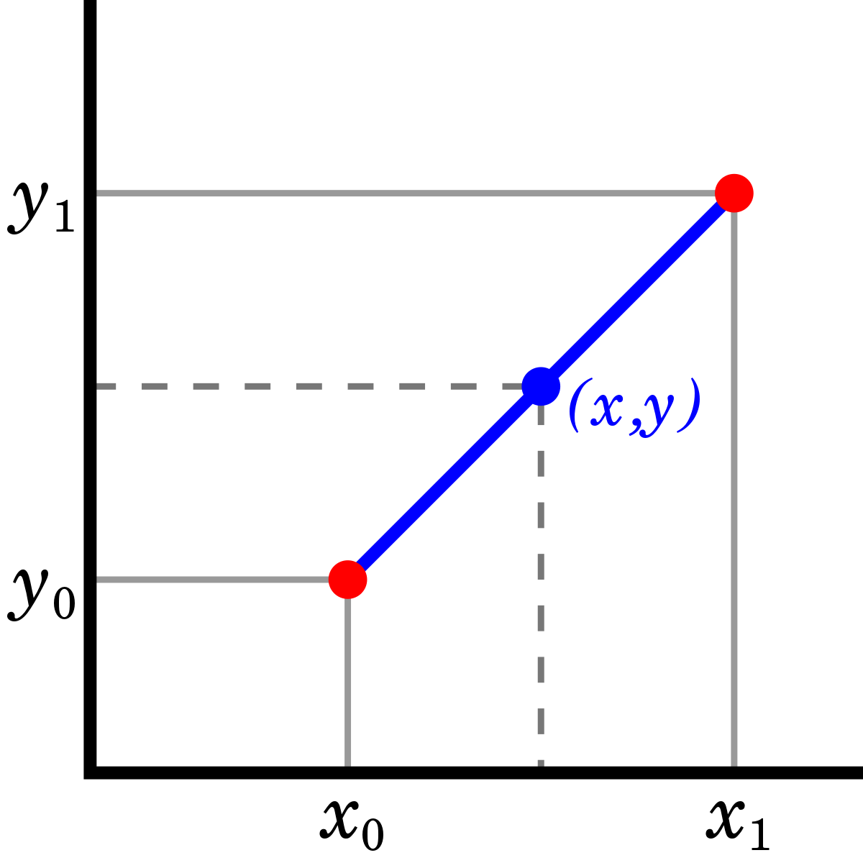

## Property calculation by phase

### Liquid

In the liquid region, properties are calculated using interpolation in the compressed-liquid tables. If these are absent for a certain fluid, or if the pressure is too low to be in that table, the incompressible () assumption is used. Consequently, if pressure is not an input property and the incompressible assumption is used, pressure will not be accurately calculated.

### Liquid-vapor mixture

In the liquid-vapor mixture region, properties are linearly dependent on the quality (mass fraction of vapor). Properties are calculated as being between the saturated liquid and saturated vapor values.

### Vapor

In the vapor region, properties are calculated using interpolation in the superheated-vapor tables. If the state is too close to the saturated vapor line, an alternate algorithm is used that incorporates saturated vapor data.

## Example of the process

Let’s take as an example, the input T = 100 Celsius, v = 10 m^3/kg. The saturated vapor specific volume at this temperature is 1.673 m^3/kg, so the state is vapor. In the superheated vapor table, we have data for 80 C and 120 C at pressures 0.06 to 1 bar. These are shown in the table below. The rows in red are pressures beyond which there is no 100 C data, so they are thrown out.

Now we interpolate to find the data for T = 100 Celsius at each of those pressures. This gives us a table where every entry is at T = 100, but pressure, specific volume, etc. are all changing. This is shown below.

Finally, we interpolate within that table using v = 10 m^3/kg. This gives us all the other properties, pressure, specific entropy, etc. This result is shown below, with the inputs highlighted in green.

The algorithm checks during each interpolation step that the data (T = 130 Celsius, v = 1.3 m^3/kg) is within the tables. We could follow a similar process if we knew temperature and specific entropy, or another combination of properties.

## Limitations

The property calculation algorithm has limitations. First, the two properties must be independent, so in the liquid-vapor mixture region, pressure and temperature would not be a valid input. Second, the table data is limited, and in some regions sparse. The algorithm does checks at each step whether the input data is within the bounds of the table. If the data is out of bounds, it should return a warning. In some regions where data is sparse, nonstandard methods are used. The incompressible assumption is used in the liquid region, where compressed-liquid data is not available. An alternate interpolation method is used near the saturation curve.

# Example problem

This example problem is example 4.3 from the thermodynamics textbook, refer to that for context.

The initial state is given by = 40 bar, = 400°C, and = 10 m/s. The final state is given by = 15 bar and = 665 m/s.

We input pressure and temperature into the app and find = 3.2136e3 kJ/kg, which agrees with the book. The equations using mass balance and energy balance reduce to:

Evaluating gives 2992.5 kJ/kg. Then, entering this state by pressure and specific enthalpy into the app gives a specific volume of 0.1627 m^3/kg, which agrees with the book.

## States tab

After entering the properties for the initial and final state, the states tab will look like this:

## Processes tab

We can set up a process from a to b. It will be unknown because it is not adiabatic, isothermal, etc.

## Plots tab

### P-V diagram

### T-S diagram

